UNIT-2
Process: A process is a program in execution. The execution of a process must progress in a sequential fashion. Definition of process is following. A process is defined as an entity which represents the basic unit of work to be implemented in the system. Components of process are following. A program is passive entity whereas a process is an active entity. A program can be transformed to process in 2 ways: by double clicking the file and typing the file from command prompt.
Process memory is divided into four sections as shown:
- The text section comprises the compiled program code, read in from non-volatile storage when the program is launched.
- The data section stores global and static variables, allocated and initialized prior to executing main.
- The heap is used for dynamic memory allocation, and is managed via calls to new, delete, malloc, free, etc.
- The stack is used for local variables. Space on the stack is reserved for local variables when they are declared ( at function entrance or elsewhere, depending on the language ), and the space is freed up when the variables go out of scope. Note that the stack is also used for function return values, and the exact mechanisms of stack management may be language specific.
- Note that the stack and the heap start at opposite ends of the process's free space and grow towards each other. If they should ever meet, then either a stack overflow error will occur, or else a call to new or malloc will fail due to insufficient memory available.
- When processes are swapped out of memory and later restored, additional information must also be stored and restored. Key among them are the program counter and the value of all program registers.
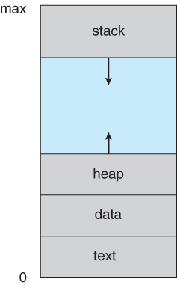

Process States: Processes may be in one of 5 states as shown:
- New - The process is in the stage of being created.
- Ready - The process has all the resources available that it needs to run, but the CPU is not currently working on this process's instructions.
- Running - The CPU is working on this process's instructions.
- Waiting - The process cannot run at the moment, because it is waiting for some resource to become available or for some event to occur. For example the process may be waiting for keyboard input, disk access request, inter-process messages, a timer to go off, or a child process to finish.
- Terminated - The process has completed.

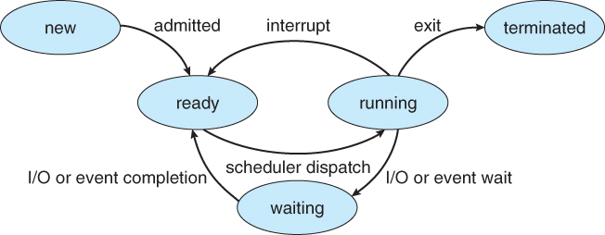
Process Control Block (PCB)
Each process is represented in the operating system by a process control block (PCB) also called a task control block. PCB is the data structure Process Control Block (PCB)
Each process is represented in the operating system by a process control block (PCB) also called a task control block. PCB is the data structure used by the operating system. Operating system groups all information that needs about particular process. PCB contains many pieces of information associated with a specific process which is described below.
S.N. | Information & Description
1 | Pointer  Pointer points to another process control block. Pointer is used for maintaining the scheduling list.
2 | Process State  Process state may be new, ready, running, waiting and so on.
3 | Program Counter  Program Counter indicates the address of the next instruction to be executed for this process.
4 | CPU registers  CPU registers include general purpose register, stack pointers, index registers and accumulators etc. number of register and type of register totally depends upon the computer architecture.
5 | Memory management information  This information may include the value of base and limit registers, the page tables, or the segment tables depending on the memory system used by the operating system. This information is useful for de-allocating the memory when the process terminates.
6 | Accounting information  This information includes the amount of CPU and real time used, time limits, job or process numbers, account numbers etc.
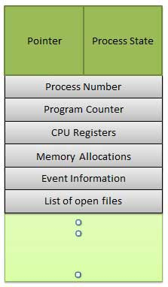
Process Control Block (PCB) includes CPU scheduling, I/O resource management, file management information etc.. The PCB serves as the repository for any information which can vary from process to process. Loader/linker sets flags and registers when a process is created. If that process gets suspended, the contents of the registers are saved on a stack and the pointer to the particular stack frame is stored in the PCB. By this technique, the hardware state can be restored so that the process can be scheduled to run again.
Process Scheduling
The process scheduling is the activity of the process manager that handles the removal of the running process from the CPU and the selection of another process on the basis of a particular strategy. It is an essential part of a Multiprogramming operating system. Such operating systems allow more than one process to be loaded into the executable memory at a time and loaded process shares the CPU using time multiplexing.
Scheduling Queues
- All processes are stored in the job queue.
- Processes in the Ready state are placed in the ready queue.
- Processes waiting for a device to become available or to deliver data are placed in device queues. There is generally a separate device queue for each device.
- Other queues may also be created and used as needed.
Queuing diagram:
- Queue is represented by rectangular box.
- The circles represent the resources that serve the queues.
- The arrows indicate the process flow in the system.
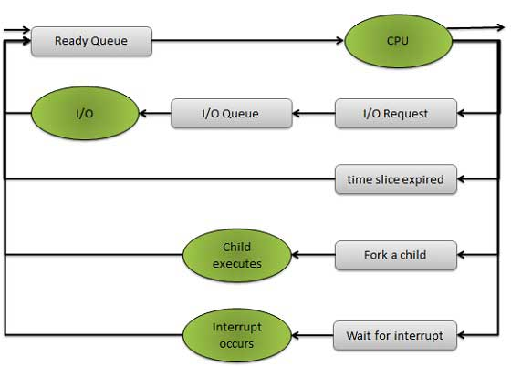
Schedulers
Schedulers are special system software’s which handles process scheduling in various ways.Their main task is to select the jobs to be submitted into the system and to decide which process to run. Schedulers are of three types:
- Long Term Scheduler
- Short Term Scheduler
- Medium Term Scheduler
Long Term Scheduler
It is also called a job scheduler. Long term scheduler determines which programs are admitted to the system for processing. Job scheduler selects processes from the queue and loads them into memory for execution. The primary objective of the job scheduler is to provide a balanced mix of jobs, such as I/O bound and processor bound. It also controls the degree of multiprogramming. If the degree of multiprogramming is stable, then the average rate of process creation must be equal to the average departure rate of processes leaving the system.
On some systems, the long term scheduler may not be available or minimal. Time-sharing operating systems have no long term scheduler. When process changes the state from new to ready, then there is use of long term scheduler.
Short Term Scheduler
It is also called CPU scheduler. Main objective is increasing system performance in accordance with the chosen set of criteria. It is the change of ready state to running state of the process. CPU scheduler selects process among the processes that are ready to execute and allocates CPU to one of them.
Short term scheduler also known as dispatcher, executed most frequently and makes the fine grained decision of which process to execute next. Short term scheduler is faster than Long term scheduler.
Medium Term Scheduler
Medium term scheduling is part of the swapping. It removes the processes from the memory. It reduces the degree of multiprogramming. The medium term scheduler is in-charge of handling the swapped out-processes.
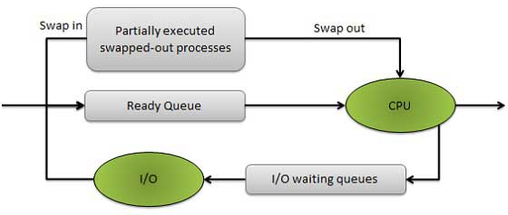
Running process may become suspended if it makes an I/O request. Suspended processes cannot make any progress towards completion. In this condition, to remove the process from memory and make space for other process, the suspended process is moved to the secondary storage. This process is called swapping, and the process is said to be swapped out or rolled out. Swapping may be necessary to improve the process mix.
Comparison between Schedulers
S.N. | Long Term Scheduler | Short Term Scheduler | Medium Term Scheduler
1 | It is a job scheduler | It is a CPU scheduler | It is a process swapping scheduler.
2 | Speed is lesser than short term scheduler | Speed is fastest among other two | Speed is in between both short and long term scheduler.
3 | It controls the degree of multiprogramming | It provides lesser control over degree of multiprogramming | It reduces the degree of multiprogramming.
4 | It is almost absent or minimal in time sharing system | It is also minimal in time sharing system | It is a part of Time sharing systems.
5 | It selects processes from pool and loads them into memory for execution | It selects those processes which are ready to execute | It can re-introduce the process into memory and execution can be continued.

Context Switch
A context switch is the mechanism to store and restore the state or context of a CPU in Process Control block so that a process execution can be resumed from the same point at a later time. Using this technique a context switcher enables multiple processes to share a single CPU. Context switching is an essential part of a multitasking operating system features. When the scheduler switches the CPU from executing one process to execute another, the context switcher saves the content of all processor registers for the process being removed from the CPU, in its process descriptor. The context of a process is represented in the process control block of a process.
Context switch time is pure overhead. Context switching can significantly affect performance as modern computers have a lot of general and status registers to be saved. Content switching times are highly dependent on hardware support. Context switch requires ( n + m ) bxK time units to save the state of the processor with ‘n’ general registers, assuming ‘b’ are the store operations are required to save ‘n’ and ‘m’ registers of two process control blocks and each store instruction requires ‘K’ time units.
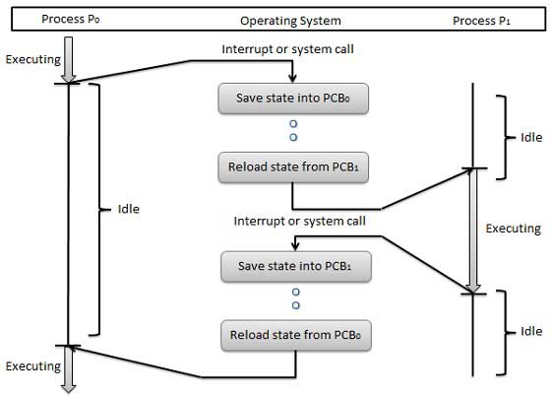
Some hardware systems employ two or more sets of processor registers to reduce the amount of context switching time. When the process is switched, the following information is stored.
- Program Counter
- Scheduling Information
- Base and limit register value
- Currently used register
- Changed State
- I/O State
- Accounting
CPU Scheduler
Selects from among the processes in memory that are ready to execute, and allocates the CPU to one of them
CPU scheduling decisions may take place when a process:
1. Switches from running to waiting state
2. Switches from running to ready state
3. Switches from waiting to ready
4. Terminates
Scheduling under 1 and 4 is non-preemptive and all other scheduling is preemptive

Dispatcher
- Dispatcher module gives control of the CPU to the process selected by the short-term scheduler; this involves:
- switching context
- switching to user mode
- jumping to the proper location in the user program to restart that program
- Dispatch latency – time it takes for the dispatcher to stop one process and start another running
Scheduling Criteria
- CPU utilization – keep the CPU as busy as possible
- Throughput – # of processes that complete their execution per time unit
- Turnaround time – amount of time to execute a particular process
- Waiting time – amount of time a process has been waiting in the ready queue
- Response time – amount of time it takes from when a request was submitted until the first response is produced, not output (for time-sharing environment)
- Max CPU utilization
- Max throughput
- Min turnaround time
- Min waiting time
- Min response time
Scheduling algorithms
Four major scheduling algorithms here which are following :
- First Come First Serve (FCFS) Scheduling
- Shortest-Job-First (SJF) Scheduling
- Priority Scheduling
- Round Robin(RR) Scheduling

First Come First Serve (FCFS)
- Jobs are executed on first come, first serve basis.
- Easy to understand and implement.
- Poor in performance as average wait time is high.
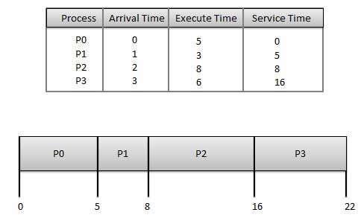
Wait time of each process is following
Process | Wait Time : Service Time - Arrival Time
P0 | 0 - 0 = 0
P1 | 5 - 1 = 4
P2 | 8 - 2 = 6
P3 | 16 - 3 = 13
Average Wait Time: (0+4+6+13) / 4 = 5.55

Shortest Job First (SJF)
- Best approach to minimize waiting time.
- Impossible to implement
- Processer should know in advance how much time process will take.
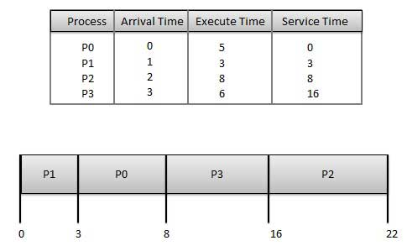

Wait time of each process is following
Process | Wait Time : Service Time - Arrival Time
P0 | 3 - 0 = 3
P1 | 0 - 0 = 0
P2 | 16 - 2 = 14
P3 | 8 - 3 = 5
Average Wait Time: (3+0+14+5) / 4 = 5.50

Priority Based Scheduling
- Each process is assigned a priority. Process with highest priority is to be executed first and so on.
- Processes with same priority are executed on first come first serve basis.
- Priority can be decided based on memory requirements, time requirements or any other resource requirement.
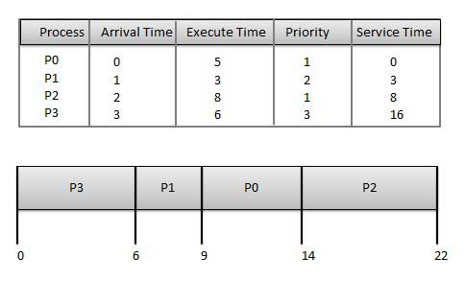
Wait time of each process is following
Process | Wait Time : Service Time - Arrival Time
P0 | 9 - 0 = 9
P1 | 6 - 1 = 5
P2 | 14 - 2 = 12
P3 | 0 - 0 = 0
Average Wait Time: (9+5+12+0) / 4 = 6.5

Round Robin Scheduling
- Each process is provided a fix time to execute called quantum.
- Once a process is executed for given time period. Process is preempted and other process executes for given time period.
- Context switching is used to save states of preempted processes.
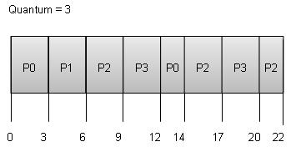
Wait time of each process is following
Process | Wait Time : Service Time - Arrival Time
P0 | (0-0) + (12-3) = 9
P1 | (3-1) = 2
P2 | (6-2) + (14-9) + (20-17) = 12
P3 | (9-3) + (17-12) = 11

Average Wait Time: (9+2+12+11) / 4 = 8.5
1. Multilevel Queue

- Ready queue is partitioned into separate queues:
foreground (interactive) background (batch)
- Each queue has its own scheduling algorithm
- foreground – RR
- background – FCFS
- Scheduling must be done between the queues
- Fixed priority scheduling; (i.e., serve all from foreground then from background). Possibility of starvation.
- Time slice – each queue gets a certain amount of CPU time which it can schedule amongst its processes; i.e., 80% to foreground in RR
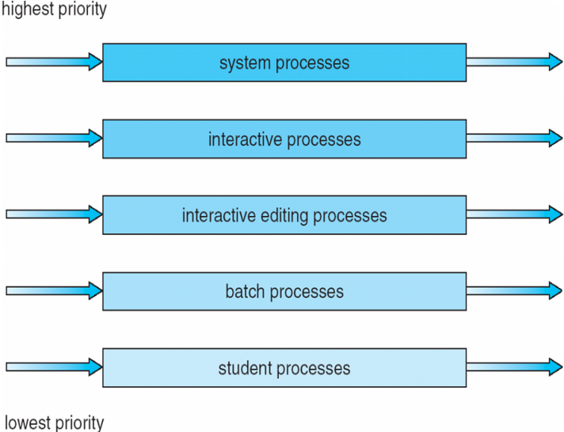
20% to background in FCFS

2.Multilevel Feedback Queue

- A process can move between the various queues; aging can be implemented this way
- Multilevel-feedback-queue scheduler defined by the following parameters:
- number of queues
- scheduling algorithms for each queue
- method used to determine when to upgrade a process
- method used to determine when to demote a process
- method used to determine which queue a process will enter when that process needs service
Example of Multilevel Feedback Queue

Three queues:
- Q0 – RR with time quantum 8 milliseconds
- Q1 – RR time quantum 16 milliseconds
- Q2 – FCFS
- Scheduling
- A new job enters queue Q0which is servedFCFS. When it gains CPU, job receives 8 milliseconds. If it does not finish in 8 milliseconds, job is moved to queue Q1.
- At Q1 job is again served FCFS and receives 16 additional milliseconds. If it still does not complete, it is preempted and moved to queue Q2.
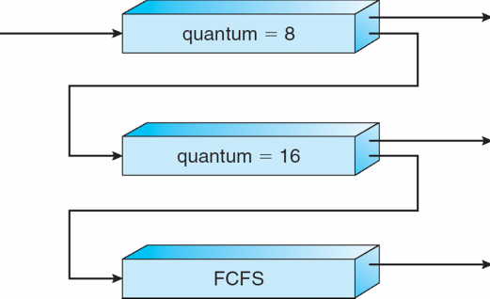
Multilevel Feedback Queues

Thread Concepts:
A thread is a flow of execution through the process code, with its own program counter, system registers and stack. A thread is also called a light weight process. Threads provide a way to improve application performance through parallelism. Threads represent a software approach to improving performance of operating system by reducing the overhead thread is equivalent to a classical process.
Each thread belongs to exactly one process and no thread can exist outside a process. Each thread represents separate flows of control.Threads have been successfully used in implementing network servers and web server. They also provide a suitable foundation for parallel execution of applications on shared memory multiprocessors. Following figure shows the working of the single and multithreaded processes.
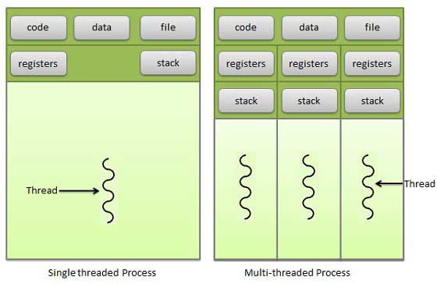

Difference between Process and Thread
S.N. | Process | Thread
1 | Process is heavy weight or resource intensive. | Thread is light weight taking lesser resources than a process.
2 | Process switching needs interaction with operating system. | Thread switching does not need to interact with operating system.
3 | In multiple processing environments each process executes the same code but has its own memory and file resources. | All threads can share same set of open files, child processes.
4 | If one process is blocked then no other process can execute until the first process is unblocked. | While one thread is blocked and waiting, second thread in the same task can run.
5 | Multiple processes without using threads use more resources. | Multiple threaded processes use fewer resources.
6 | In multiple processes each process operates independently of the others. | One thread can read, write or change another thread's data.

Advantages of Threads
- Threads minimize context switching time.
- Use of threads provides concurrency within a process.
- Efficient communication.
- Economy- It is more economical to create and context switch threads.
- Utilization of multiprocessor architectures to a greater scale and efficiency.

Types of Threads
Threads are implemented in following two ways:
- User Level Threads -- User managed threads
- Kernel Level Threads -- Operating System managed threads acting on kernel, an operating system core.

User Level Threads: In this case, application manages thread management, kernel is not aware of the existence of threads. The thread library contains code for creating and destroying threads, for passing message and data between threads, for scheduling thread execution and for saving and restoring thread contexts. The application begins with a single thread and begins running in that thread.
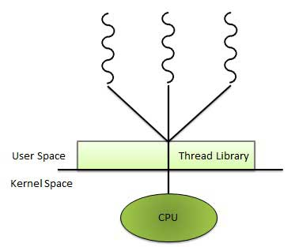

Advantages
- Thread switching does not require Kernel mode privileges.
- User level thread can run on any operating system.
- Scheduling can be application specific in the user level thread.
- User level threads are fast to create and manage.

Disadvantages
- In a typical operating system, most system calls are blocking.
- Multithreaded application cannot take advantage of multiprocessing.

Kernel Level Threads
In this case, thread management is done by the Kernel. There is no thread management code in the application area. Kernel threads are supported directly by the operating system. Any application can be programmed to be multithreaded. All of the threads within an application are supported within a single process.
The Kernel maintains context information for the process as a whole and for individual threads within the process. Scheduling by the Kernel is done on a thread basis. The Kernel performs thread creation, scheduling and management in Kernel space. Kernel threads are generally slower to create and manage than the user threads.

Advantages
- Kernel can simultaneously schedule multiple threads from the same process on multiple processes.
- If one thread in a process is blocked, the Kernel can schedule another thread of the same process.
- Kernel routines themselves can multithreaded.

Disadvantages
- Kernel threads are generally slower to create and manage than the user threads.
- Transfer of control from one thread to another within same process requires a mode switch to the Kernel.

Multithreading Models
Some operating system provides a combined user level thread and Kernel level thread facility. Solaris is a good example of this combined approach. In a combined system, multiple threads within the same application can run in parallel on multiple processors and a blocking system call need not block the entire process. Multithreading models are three types :
- Many to many relationship.
- Many to one relationship.
- One to one relationship.

Many to Many Models
In this model, many user level threads multiplex to the Kernel thread of smaller or equal numbers. The number of Kernel threads may be specific to either a particular application or a particular machine.
Following diagram shows the many to many models. In this model, developers can create as many user threads as necessary and the corresponding Kernel threads can run in parallels on a multiprocessor.
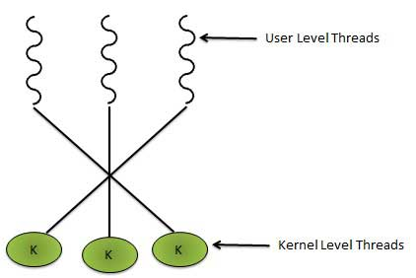

Many to One Model
Many to one model maps many user level threads to one Kernel level thread. Thread management is done in user space. When thread makes a blocking system call, the entire process will be blocks. Only one thread can access the Kernel at a time,so multiple threads are unable to run in parallel on multiprocessors.
If the user level thread libraries are implemented in the operating system in such a way that system does not support them then Kernel threads use the many to one relationship modes.
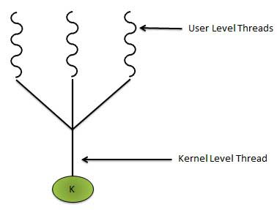

One to One Model
There is one to one relationship of user level thread to the kernel level thread.This model provides more concurrency than the many to one model. It allows another thread to run when a thread makes a blocking system call. It supports multiple threads to execute in parallel on microprocessors.
Disadvantage of this model is that creating user thread requires the corresponding Kernel thread. OS/2 , Windows NT and Windows 2000 use one to one relationship model.
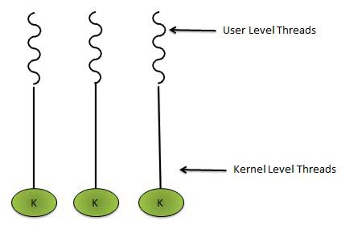

Difference between User Level & Kernel Level Thread
S.N. | User Level Threads | Kernel Level Thread
1 | User level threads are faster to create and manage. | Kernel level threads are slower to create and manage.
2 | Implementation is by a thread library at the user level. | Operating system supports creation of Kernel threads.
3 | User level thread is generic and can run on any operating system. | Kernel level thread is specific to the operating system.
4 | Multi-threaded application cannot take advantage of multiprocessing. | Kernel routines themselves can be multithreaded.

Process Synchronization

- To introduce the critical-section problem, whose solutions can be used to ensure the consistency of shared data
- To present both software and hardware solutions of the critical-section problem
- To introduce the concept of an atomic transaction and describe mechanisms to ensure atomicity

- Concurrent access to shared data may result in data inconsistency
- Maintaining data consistency requires mechanisms to ensure the orderly execution of cooperating processes
- Suppose that we wanted to provide a solution to the consumer-producer problem that fills all the buffers. We can do so by having an integer count that keeps track of the number of full buffers. Initially, count is set to 0. It is incremented by the producer after it produces a new buffer and is decremented by the consumer after it consumes a buffer

Producer

while (true) {

/* produce an item and put in nextProduced */
while (count == BUFFER_SIZE)
; // do nothing
buffer [in] = nextProduced;
in = (in + 1) % BUFFER_SIZE;
count++;
}
Consumer
while (true) {
while (count == 0)
; // do nothing
nextConsumed = buffer[out];
out = (out + 1) % BUFFER_SIZE;
count--;

/* consume the item in nextConsumed
}
Race Condition
count++ could be implemented as
register1 = count
register1 = register1 + 1
count = register1
count-- could be implemented as
register2 = count
register2 = register2 - 1
count = register2
Consider this execution interleaving with “count = 5” initially:
S0: producer execute register1 = count {register1 = 5}
S1: producer execute register1 = register1 + 1 {register1 = 6}
S2: consumer execute register2 = count {register2 = 5}
S3: consumer execute register2 = register2 - 1 {register2 = 4}
S4: producer execute count = register1 {count = 6 }
S5: consumer execute count = register2 {count = 4}
Solution to Critical-Section Problem

1. Mutual Exclusion - If process Pi is executing in its critical section, then no other processes can be executing in their critical sections
2. Progress - If no process is executing in its critical section and there exist some processes that wish to enter their critical section, then the selection of the processes that will enter the critical section next cannot be postponed indefinitely
3. Bounded Waiting - A bound must exist on the number of times that other processes are allowed to enter their critical sections after a process has made a request to enter its critical section and before that request is granted
- Assume that each process executes at a nonzero speed
- No assumption concerning relative speed of the N processes

Peterson’s Solution

- Two process solution
- Assume that the LOAD and STORE instructions are atomic; that is, can’t be interrupted.
- The two processes share two variables:
- int turn;
- Boolean flag[2]
- The variable turn indicates whose turn it is to enter the critical section.
- The flag array is used to indicate if a process is ready to enter the critical section. flag[i] = true implies that process Pi is ready!
Algorithm for Process Pi
do {
flag[i] = TRUE;
turn = j;
while (flag[j] && turn == j);
critical section
flag[i] = FALSE;
remainder section
} while (TRUE);

Synchronization Hardware

- Many systems provide hardware support for critical section code
- Uniprocessors – could disable interrupts
- Currently running code would execute without preemption
- Generally too inefficient on multiprocessor systems
Operating systems using this not broadly scalable
- Modern machines provide special atomic hardware instructions
Atomic = non-interruptable
- Either test memory word and set value Or swap contents of two memory words

Solution to Critical-section Problem Using Locks
do {
acquire lock
critical section
release lock
remainder section
} while (TRUE);

TestAndSet Instruction
Definition:

booleanTestAndSet (boolean *target)
{
booleanrv = *target;
*target = TRUE;
returnrv:
}

Solution using TestAndSet

Shared boolean variable lock., initialized to false.
Solution:

do {
while ( TestAndSet (&lock ))
; // do nothing

// critical section

lock = FALSE;

// remainder section

} while (TRUE);

Swap Instruction

Definition:

void Swap (boolean *a, boolean *b)
{
boolean temp = *a;
*a = *b;
*b = temp:
}

Solution using Swap

Shared Boolean variable lock initialized to FALSE; Each process has a local Boolean variable key
Solution:
do {
key = TRUE;
while ( key == TRUE)
Swap (&lock, &key );

// critical section

lock = FALSE;

// remainder section

} while (TRUE);
Bounded-waiting Mutual Exclusion with TestandSet()
do {
waiting[i] = TRUE;
key = TRUE;
while (waiting[i] && key)
key = TestAndSet(&lock);
waiting[i] = FALSE;
// critical section
j = (i + 1) % n;
while ((j != i) && !waiting[j])
j = (j + 1) % n;
if (j == i)
lock = FALSE;
else
waiting[j] = FALSE;
// remainder section
} while (TRUE);

Semaphore
- Synchronization tool that doesnt require busy waiting
- . Semaphore S is integer variable
- Two standard operations modify S: wait() and signal()
- Originally called P() andV()
- Less complicated
- Can only be accessed via two indivisible (atomic) operations
wait (S) {
while S <= 0
; // no-op
S--;
}
signal (S) {
S++;
}

Semaphore as General Synchronization Tool

- Counting semaphore – integer value can range over an unrestricted domain
- Binary semaphore – integer value can range between 0 & 1; simpler to implement
- Also known as mutex locks
- . Can implement a counting semaphore S as a binary semaphore
- Provides mutual exclusion
Semaphoremutex; // initialized to
do {
wait (mutex);
// Critical Section
signal (mutex);
// remainder section
} while (TRUE);

Semaphore Implementation
- Must guarantee that no two processes can execute wait () and signal () on the same semaphore at the same time
- Thus, implementation becomes the critical section problem where the wait and signal code are placed in the crtical section.
- Could now have busy waiting in critical section implementation
But implementation code is short
Little busy waiting if critical section rarely occupied
- Note that applications may spend lots of time in critical sections and therefore this is not a good solution.
Semaphore Implementation with no Busy waiting

- With each semaphore there is an associated waiting queue. Each entry in a waiting queue has two data items:
- value (of type integer)
- pointer to next record in the list

- Two operations:
- block – place the process invoking the operation on the appropriate waiting queue.
- wakeup – remove one of processes in the waiting queue and place it in the ready queue.

Implementation of wait:
wait(semaphore *S) {
S->value--;
if (S->value < 0) {
add this process to S->list;
block();
}
}
Implementation of signal:

signal(semaphore *S) {
S->value++;
if (S->value <= 0) {
remove a process P from S->list;
wakeup(P);
}
}

Deadlock and Starvation
- Deadlock – two or more processes are waiting indefinitely for an event that can be caused by only one of the waiting processes
- Let S and Q be two semaphores initialized to 1
P0 P1

wait (S); wait (Q);
wait (Q); wait (S);
. .
. .
signal (S); signal (Q);
signal (Q); signal (S);
- Starvation – indefinite blocking. A process may never be removed from the semaphore queue in which it is suspended
- Priority Inversion - Scheduling problem when lower-priority process holds a lock needed by higher-priority process

Classical Problems of Synchronization
- Bounded-Buffer Problem
- Readers and Writers Problem
- Dining-Philosophers Problem

Bounded-Buffer Problem

- N buffers, each can hold one item
- Semaphore mutex initialized to the value 1
- Semaphore full initialized to the value 0
- Semaphore empty initialized to the value N.

The structure of the producer process

do {
// produce an item in nextp

wait (empty);
wait (mutex);

// add the item to the buffer

signal (mutex);
signal (full);
} while (TRUE);

The structure of the consumer process

do {
wait (full);
wait (mutex);

// remove an item from buffer to nextc

signal (mutex);
signal (empty);
// consume the item in nextc

} while (TRUE);

Readers-Writers Problem A data set is shared among a number of concurrent processes
- Readers – only read the data set; they do not perform any updates
- Writers – can both read and write
- nProblem – allow multiple readers to read at the same time. Only one single writer can access the shared data at the same time

- Shared Data
- Data set
- Semaphore mutex initialized to 1
- Semaphore wrt initialized to 1
- Integer readcount initialized to 0

The structure of a writer process
do {
wait (wrt) ;
// writing is performed

signal (wrt) ;
} while (TRUE);

The structure of a reader process

do {
wait (mutex) ;
readcount ++ ;
if (readcount == 1)
wait (wrt) ;
signal (mutex)
// reading is performed

wait (mutex) ;
readcount - - ;
if (readcount == 0)
signal (wrt) ;
signal (mutex) ;
} while (TRUE);

Dining-Philosophers Problem

Shared data
- Bowl of rice (data set)
- Semaphore chopstick [5] initialized to 1

- The structure of Philosopher i:

do {
wait ( chopstick[i] ); wait ( chopStick[ (i + 1) % 5] );
// eat

signal ( chopstick[i] ); signal (chopstick[ (i + 1) % 5] );
// think

} while (TRUE);

Problems with Semaphores
Incorrect use of semaphore operations:

signal (mutex)
….
wait (mutex)

wait (mutex) …

Omitting of wait (mutex) or signal (mutex) (or both)
Monitors
A high-level abstraction that provides a convenient & effective mechanism for process synch.
Only one process may be active within the monitor at a time

monitor monitor-name {
// shared variable declarations
procedure P1 (…) { …. }
…

procedurePn (…) {……}

Initialization code ( ….) { … }
…
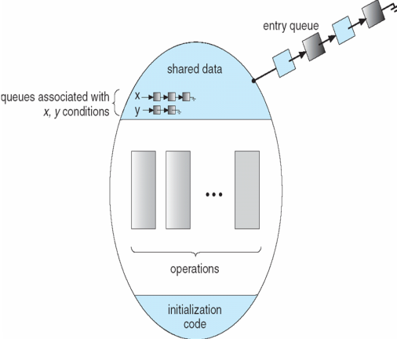
} }
Schematic view of a Monitor

Condition Variables

condition x, y;

Two operations on a condition variable:
x.wait () – a process that invokes the operation is suspended.
x.signal()–resumes 1 of processes(if any) that invoked x.wait() monitor with condition var’s

Solution to Dining Philosophers

monitor DP{
enum { THINKING; HUNGRY, EATING) state [5] ;
condition self [5];

void pickup (inti) {
state[i] = HUNGRY;
test(i);
if (state[i] != EATING) self [i].wait;
}
void putdown (inti) {
state[i] = THINKING;
// test left and right neighbors
test((i + 4) % 5);
test((i + 1) % 5);
}

void test (inti) {
if ( (state[(i + 4) % 5] != EATING) &&
(state[i] == HUNGRY) &&
(state[(i + 1) % 5] != EATING) ) {
state[i] = EATING ;
self[i].signal () ;
} }

initialization_code() {
for (inti = 0; i< 5; i++)
state[i] = THINKING;
} }

Each philosopher I invokes theoperations pickup()
and putdown() in the following sequence:

DiningPhilosophters.pickup (i);

EAT

DiningPhilosophers.putdown (i);

Monitor Implementation Using Semaphores
Variables
semaphoremutex; // (initially = 1)
semaphore next; // (initially = 0)
int next-count = 0;
nEach procedure F will be replaced by

wait(mutex);
…
body of F;

…
if (next_count> 0)
signal(next)
else
signal(mutex);
nMutual exclusion within a monitor is ensured.

Monitor Implementation
For each condition variable x, we have:

semaphorex_sem; // (initially = 0)
int x-count = 0;
nThe operation x.wait can be implemented as:
x-count++;
if (next_count> 0)
signal(next);
else
signal(mutex);
wait(x_sem);
x-count--;
The operation x.signal can be implemented as:

if (x-count > 0) {
next_count++;
signal(x_sem);
wait(next);
next_count--;
}
A Monitor to Allocate Single Resource
monitorResourceAllocator{
boolean busy;
condition x;
void acquire(int time) {
if (busy)
x.wait(time);
busy = TRUE;
}
void release() {
busy = FALSE;
x.signal();
}
initialization code() {
busy = FALSE;
} }

